Sensor Operation and Calibration
26 September 2020 | Andrei Florian

pH Sensor
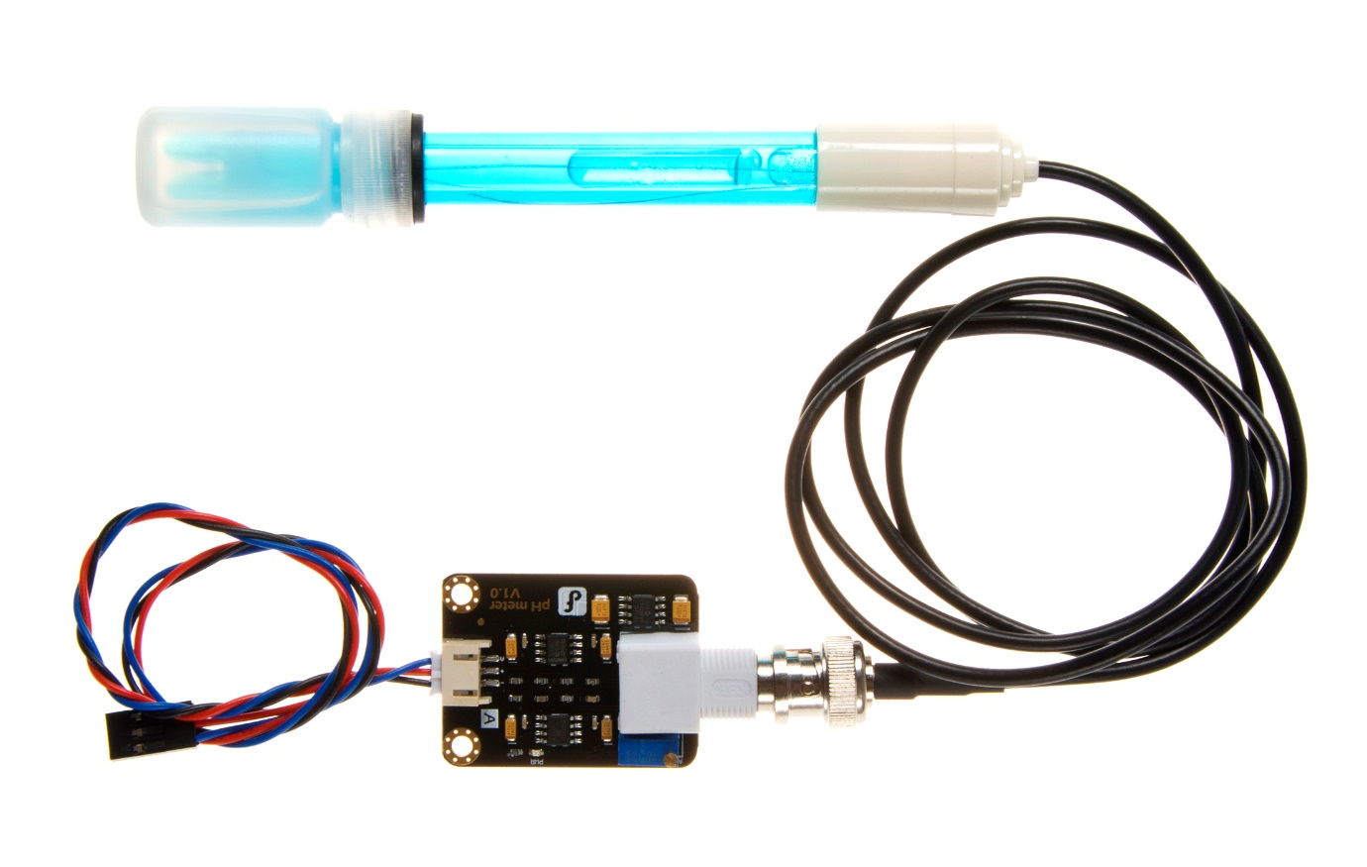

Description
This sensor aims to measure the potential of hydrogen of the body of water submerged in. The device uses an analogic interface to output the pH of the substance submerged in.
- Module Power: 5.00V
- Module Size: 43 x 32mm (1.69x1.26")
- Measuring Range :0 - 14PH
- Measuring Temperature: 0 - 60 ℃
- Accuracy: ± 0.1pH (25 ℃)
- Response Time: ≤ 1min
- pH Sensor with BNC Connector
- pH2.0 Interface (3-foot patch)
- Gain Adjustment Potentiometer
- Power Indicator LED

Purpose of Data Collection
- Marine organisms rely on a specific pH of water to live in. If the pH is abnormal, certain species may die.
- The pH of water is dictated by the substances and chemicals within it. Certain levels of different chemicals can distort the pH value. Hence the pH value is a sum of chemicals in the river which means that an abnormal pH value can indicate abnormalities in the composition of the water.

Calibration
Note that the closer the voltage used to power the device is to 5 volts, the more precise the readings from the sensor are.
- The precision of the electrode is ± 0.1pH at 25℃
- The electrode used for the first or long set without re-use, the electrode bulb, and the sand core, immersed in the 3NKCL solution activated eight hours.
- The electrode plug should be kept clean and dry.
- Electrode reference solution is the 3NKCL solution.
- Measurement should be avoided staggered pollution between solutions, so as not to affect the accuracy of measurement.
- Electrode blub or sand core is defiled which will make PTS decline, slow response. So, it should be based on the characteristics of the pollutant, adapted to the cleaning solution, the electrode performance recovery.
- The electrode should not be long-term immersed in acid chloride solution.

- The electrode must be calibrated every time it is going to be used in service. Ideally every 6 months. Because water is neutral, the calibration should take place with the probe submerged in distilled water.
- Connect the probe to the microcontroller used and upload the code ensuring that the pH calibration value (set in a variable) is set to 0.
- Record the difference between the recorded value printed and the actual pH of the water (7) and change the value of the variable from 0 to the difference.
- Now reupload the code and continue doing so until the pH printed is 7.
- Note that a wait of about a minute is needed before measuring the offset.

Use of sensor
The sensor should be placed in distilled water when not in use to prevent the damaging of the probe. This will also increase its longevity. The probe should be changed once the offset of the probe from the control value is greater than 0.3pH.
The debt of the probe does not matter provided the top of it is submerged fully in water.

Turbidity Sensor
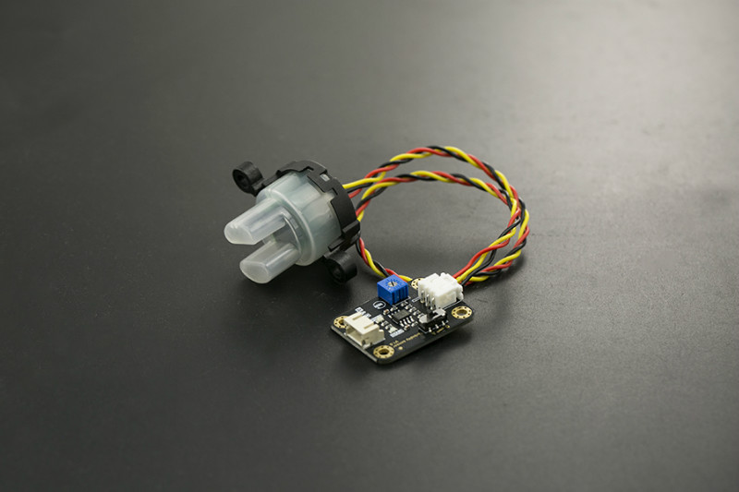

Description
The sensor detects water quality by measuring the levels of turbidity, or the opaqueness. It uses light to detect suspended particles in water by measuring the light transmittance and scattering rate, which changes with the amount of total suspended solids (TSS) in water. As the TTS increases, the liquid turbidity level increases.
- Operating Voltage: 5V DC
- Operating Current: 40mA (MAX)
- Response Time : <500ms
- Insulation Resistance: 100M (Min)
- Output Method:
- Analog output: 0-4.5V
- Digital Output: High/Low level signal (you can adjust the threshold value by adjusting the potentiometer)
- Operating Temperature: 5℃~90℃
- Storage Temperature: -10℃~90℃
- Weight: 30g
- Adapter Dimensions: 38mm*28mm*10mm/1.5inches *1.1inches*0.4inches

Purpose of Data Collection
The turbidity of the water can indicate the presence of suspended particles in the water. Turbidity is measured in NTUs (1NTU = 1 mg/L of insoluble impurities).
- This can indicate that the water is dirty with insoluble impurities such as oil and dirt.

Calibration
The sensor does not need to be calibrated. Please note that the optimal operation voltage for the probe is between 10 and 50 degrees Celsius.
This is a reference chart for the mapping from the output voltage to the NTU according to different temperature. e.g. If you leave the sensor in the pure water, that is NTU < 0.5, it should output “4.1±0.3V” when temperature is 10~50℃.
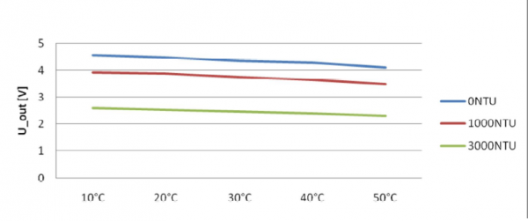

Use of Sensor
The sensor is to be fully submerged up to the black ribbon on top in the water being sampled. This will ensure that the reading is correct. Below is a graph showing the relationship between the voltage outputted by the device and the respective turbidity (in NTU).
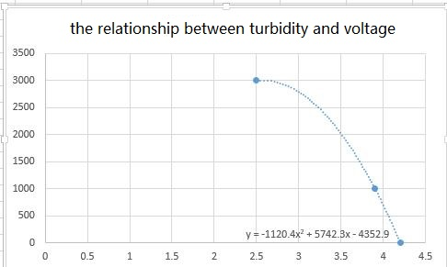

Water Temperature Sensor
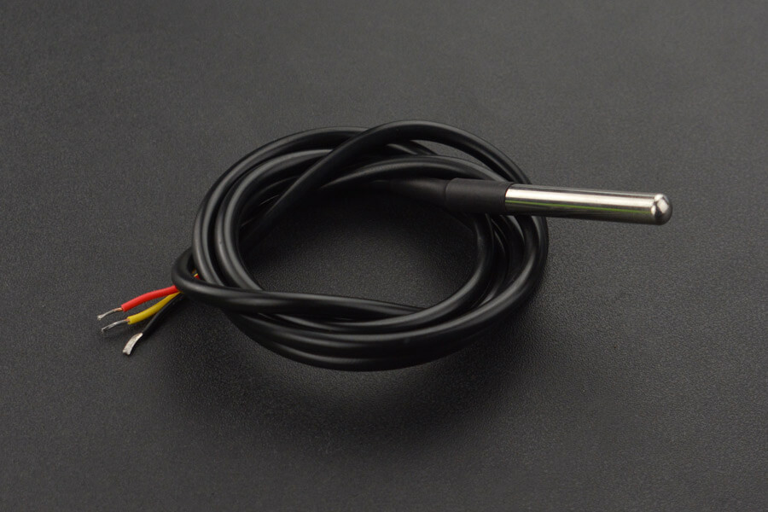

Description
The waterproof temperature sensor works by having a temperature sensor enclosed in a waterproof probe. This allows the sensor to measure temperatures up to 100 degrees Celsius while being underwater.
- Usable with 3.0V to 5.5V power/data
- ±0.5℃ Accuracy from -10℃ to +85℃
- Usable temperature range: -55 to 125℃ (-67℉ to +257℉)
- 9 to 12-bit selectable resolution
- Uses 1-Wire interface- requires only one digital pin for communication
- Unique 64-bit ID burned into chip
- Multiple sensors can share one pin
- Temperature-limit alarm system
- Query time is less than 750ms
- 3 wires interface:
- Red wire - VCC
- Black wire - GND
- Yellow wire - DATA
- Stainless steel tube 6mm diameter by 35mm long
- Cable diameter: 4mm
- Length: 90cm

Purpose of Data Collection
The temperature of the water has a great impact on marine life living in the body of water. Many species of both flora and fauna have adapted to a specific temperature range. It is essential that the temperature does not fluctuate as this may harm the organisms in the water.
The water temperature is also an indication of how insulating the water is which may hint towards heavy chemicals and greenhouse compounds in the stream.

Calibration
This sensor does not require calibration as it is ready to go. Its design also allows it to perform for a very long period with high precision. The sensor should only be changed once every couple of years.

Use of Sensor
The sensor should be submerged in the water more than the other sensors where possible. It is true that the water temperature naturally decreases the deeper the sample is taken. The probe should hence be submerged after analysing the aim of the measurement.

